**Name: Uzzal Howlader**

**Id:144221**

**School Management**

* User story

1. As a user I want to see Teacher’s list in the school.

2. As a user I want to add Teacher.

3. As a user I want to edit Teacher’s info so that I can correct ant mistakes.

4. As a user I want to view a single Teacher’s info.

5. As a user I want to delete any Teacher’s info.

* Use case:

Teacher’s list

|  |  |  |
| --- | --- | --- |
| Requirements | Key Features | Acceptance Criteria |
| As a user I want to see Teacher’s list in the school. |  | 1. Teacher’s list should be in list format.  2. Teacher names should be in serial number.  3. Teacher name should be listed in Alphabetic order.  4. Teacher list should be paginated.  5. User can choose number of items to be shown per page from a dropdown list.  6. Teacher info should download the list as XLS file. |

Add Teacher Info.

|  |  |  |
| --- | --- | --- |
| Requirements | Key Features | Acceptance Criteria |
| As a user I want to add Teacher. |  | 1. Only User can add teachers info.  2.   No empty value is accepted.(Empty Validation) |

Edit Teacher info.

|  |  |  |
| --- | --- | --- |
| Requirements | Key Features | Acceptance Criteria |
| As a user I want to edit Teacher’s info so that I can correct any mistakes. |  | No empty value is accepted.(Empty Validation) |

View Teacher info

|  |  |  |
| --- | --- | --- |
| Requirements | Key Features | Acceptance Criteria |
| As a user I want to view a single Teacher’s info. |  |  |

Delete teacher info.

|  |  |  |
| --- | --- | --- |
| Requirements | Key Features | Acceptance Criteria |
| As a user I want to delete any Teacher’s info. |  | 1.  Confirmation message should be displayed.  2.  After successfully deletion a message should be displayed. |

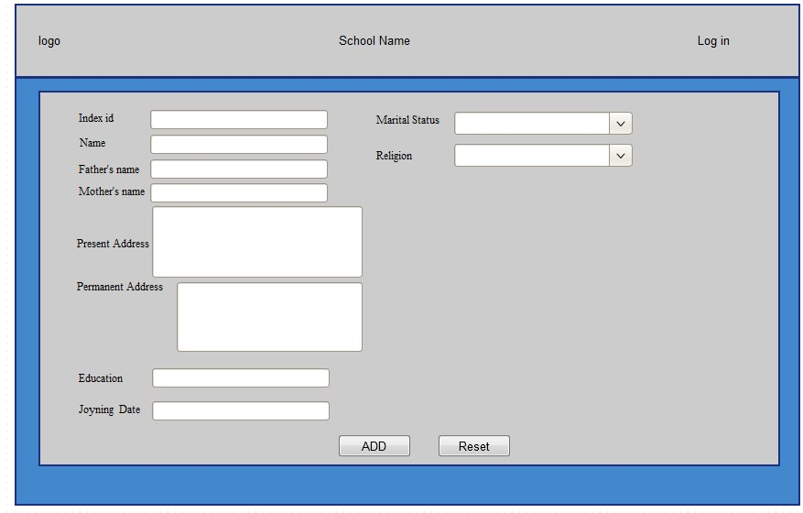

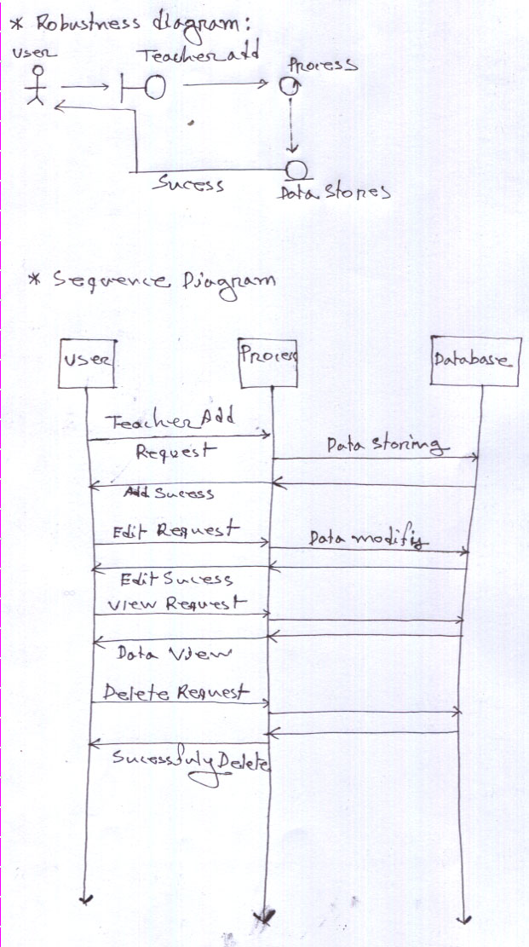  
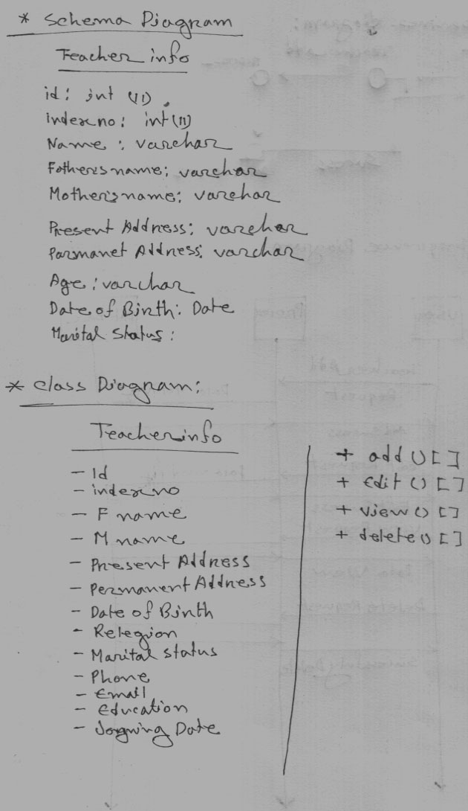

Mockup

